Interpreting an agarose gel and calculating DNA molecular weights using a standard curve

The most common method to study DNA in the laboratory is by agarose gel electrophoresis. A slab of agarose is placed in a buffer between two electrodes and an electrical field is applied (Fig 1). DNA will migrate through the agarose at a rate that depends on the size of the molecule where shorter molecules migrate faster than longer ones.

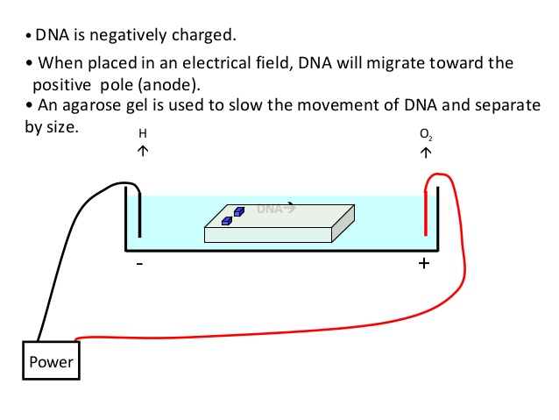Fig 1: Agarose gel electrophoresis

The migration rate depends on the size of the molecule by a simple mathematical approximation. The migration distance after a given time is equal to a constant multiplied with the logarithm of the length of the DNA molecule (Fig 2).
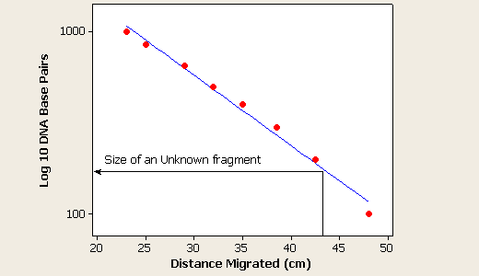Fig 2: distance vs length plot

Constructing a standard curve from a gel image starts with measuring all the distances between the front of the well and the front of the gel bands of the standard (lane S in Fig 3). The sizes of the fragments in the standard must be known.
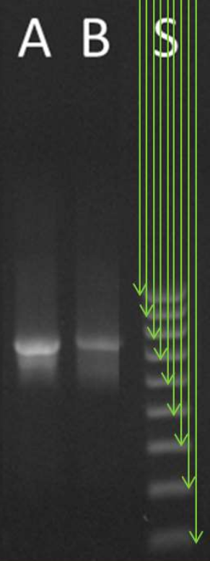Fig 3: measuring the migration distances for standard fragments

The easiest way to analyze the data is to create a spreadsheet in Google sheets, LibreOffice Calc or MS Excel (Fig 4).

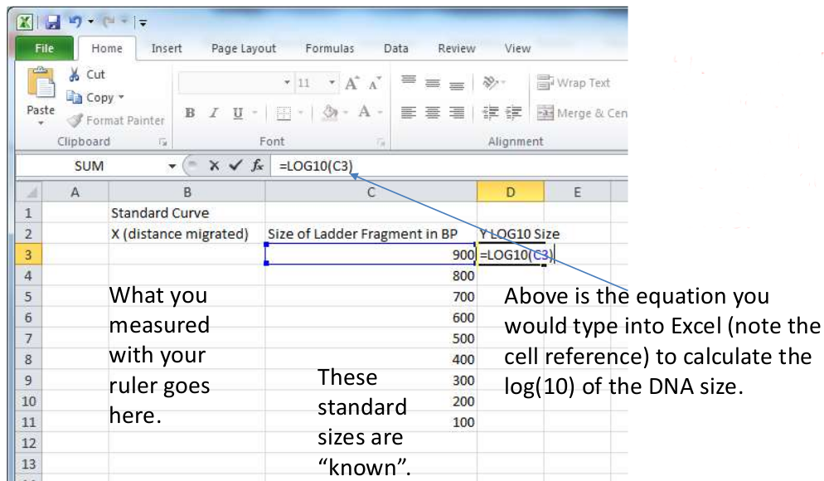Fig 4: Spreadsheet with data

Once all data is entered, create a linear plot as depicted in Fig 5. This should eventually give you a plot like the one in

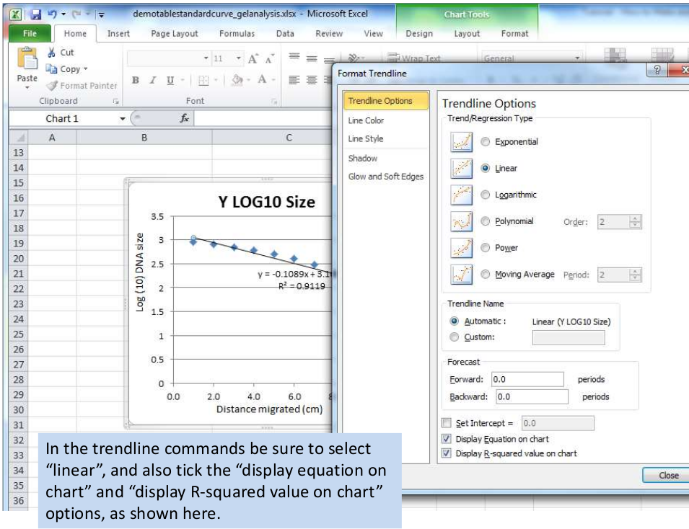Fig 5: Making a linear plot

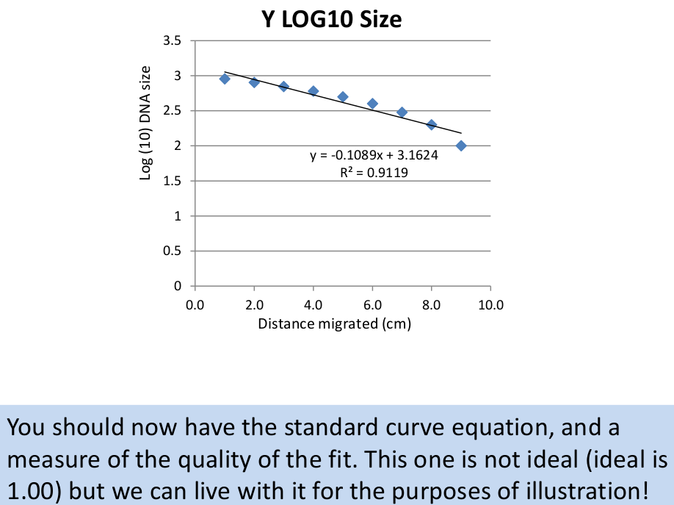Fig 6: Linear plot

The equation which should be similar to the one in Fig 6 can be used to find the length of an unknown DNA fragment in a gel. Most gels are not printed to paper anymore, so it is more practical to measure distances in an electronic gel image using some graphics program like GIMP or Photoshop.

Question 1:

There is a file called “TP13_gel_image.png” in the same folder as this file. This image shows an agarose gel with two lanes. The right lane is a molecular weight standard containign bands of the following sizes: 10.0, 8.0, 6.0, 5.0, 4.0, 3.0, 2.0, 1.5, 1.0, 0.5 kbp (kilo base pairs). The left lane has three DNA bands of unknown size. Your task is to calculate the length (in kbp) of each of the three bands. You need a spreadsheet program and a program that can be used to measure distances in images. The easiest tool to use (IMHO) is called “Online pixel ruler” where you can simply paste the image on the page without installing anything (Fig 7). Alternatively, there is PixelZoomer, an extension for Chrome and Firefox that is easy to install and available here. This page has a collection of different measuring tools.

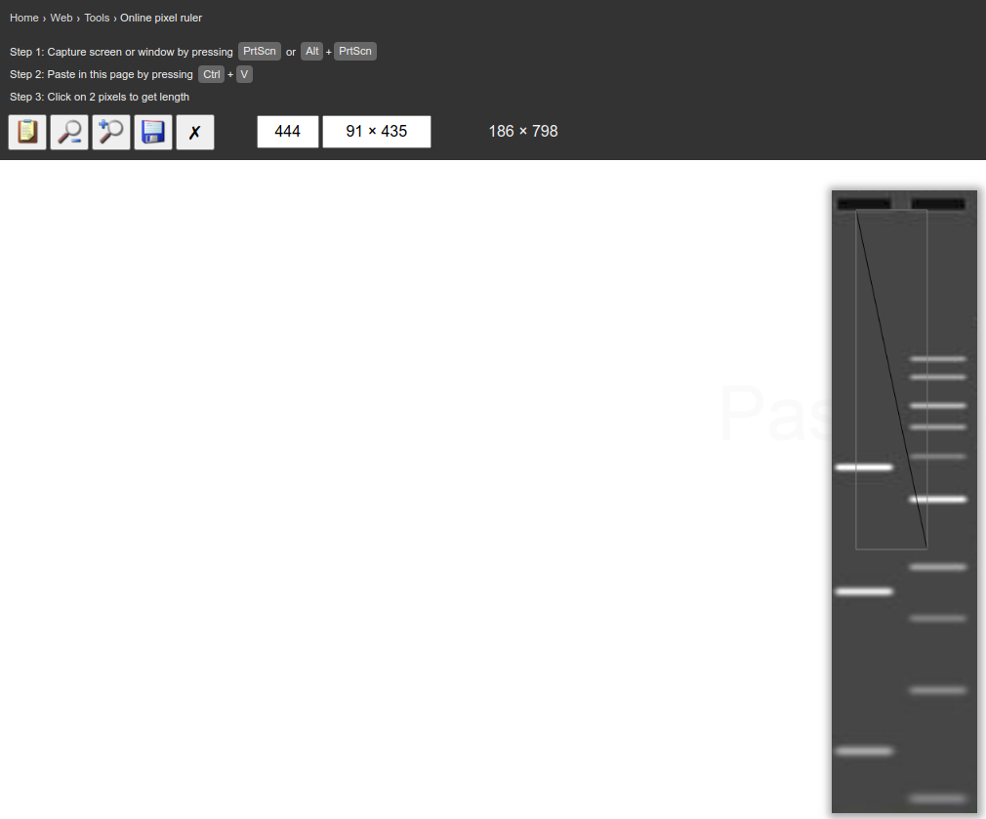Fig 7: Pixel ruler

